**SMALL LAP - A (approx 2K start - finish incl yellow short-lap section) flat undulating parkland.**

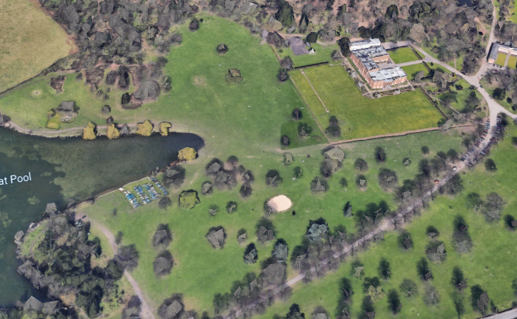

**FINISH**

**START**

**LARGE LAP - B (approx 1.2K excl. start/finish) – flat undulating parkland.**



**START**

**FINISH**

**TIMETABLE OF RACES, DISTANCES & LAP DETAILS**

**10:00 am MINOR GIRLS (2K) 1 small lap (A)**

**10:20 am MINOR BOYS (2.5K) 1 small lap (A) & 1 large lap (B)**

**10:40 am JUNIOR GIRLS (2.5K) 1 small lap (A) & 1 large lap (B)**

**11:00 am JUNIOR BOYS (3.9K) 3 large laps (B)**

**11:20 am INTER GIRLS (3.9K) 3 large laps (B)**

**11:40 am INTER BOYS (4.6K) 1 small lap (A) & 3 large laps (B)**